DrugFacts: Is Marijuana Medicine?
http://www.drugabuse.gov
Revised July2015

What is medical marijuana?
The term medical marijuana refers to using the whole unprocessed marijuana plant or its basic extracts to treat a disease or symptom. The U.S. Food and Drug Administration (FDA) has not recognized or approved the marijuana plant as medicine.

However, scientific study of the chemicals in marijuana, called cannabinoids, has led to two FDA-approved medications that contain cannabinoid chemicals in pill form. Continued research may lead to more medications.

Because the marijuana plant contains chemicals that may help treat a range of illnesses or symptoms, many people argue that it should be legal for medical purposes. In fact, a growing number of states have legalized marijuana for medical use.

What are cannabinoids?
Cannabinoids are chemicals related to delta-9-tetrahydrocannabinol (THC), marijuana’s main mind-altering ingredient. Other than THC, the marijuana plant contains more than 100 other cannabinoids.

How might cannabinoids be useful as medicine?
Currently, the two main cannabinoids from the marijuana plant that are of medical interest are THC and CBD.

THC increases appetite and reduces nausea. The FDA-approved THC-based medications are used for these purposes. THC may also decrease pain, inflammation (swelling and redness), and muscle control problems.

CBD is a cannabinoid that does not affect the mind or behavior. It may be useful in reducing pain and inflammation, controlling epileptic seizures, and possibly even treating mental illness and addictions.

Recent animal studies have shown that marijuana extracts may help kill certain cancer cells and reduce the size of others. Evidence from one cell culture study suggests that purified extracts from whole-plant marijuana can slow the growth of cancer cells from one of the most serious types of brain tumors. Research in mice showed that treatment with purified extracts of THC and CBD, when used with radiation, increased the cancer-killing effects of the radiation (Scott, 2014).

Scientists are also conducting preclinical and clinical trials with marijuana and its extracts to treat numerous diseases and conditions, such as the following:
- autoimmune diseases (diseases that weaken the immune system):
- multiple sclerosis (MS), which causes gradual loss of muscle control
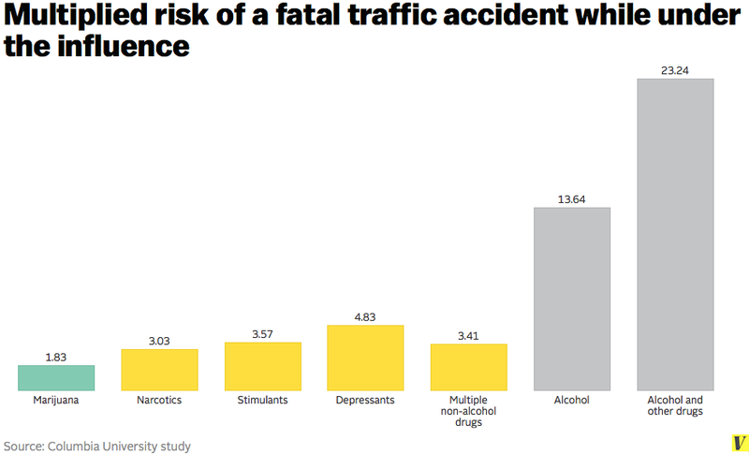
- HIV/AIDS
- Alzheimer’s disease, which causes loss of brain function, affecting memory, thinking, and behavior
- inflammation
- pain
- seizures
- substance use disorders
- mental disorders
Family moves for medical marijuana
By Amanda Rossman, Cincinnati.com

The Benton family has finally decided enough is enough. Heather Benton and her three-year-old daughter Addyson boarded a plane bound for Colorado on Thursday afternoon. Heather’s husband, Adam, and their two dogs won’t be too far behind in the moving truck.

Addyson was diagnosed with myoclonic epilepsy at 14 months old. Tests showed she was having over 1,000 seizures a day. After trying several medications unsuccessfully, the family was almost without hope.

Then they researched medical marijuana. The Bentons decided that it would be in Addyson’s best interest to give it a shot.

They were finally able to obtain a form of CBD (cannabidiol) oil, which is called Charlotte’s Web CBD for its success in halting the epileptic seizures of Charlotte Fiji, who is now 8.

“We’ve noticed instantly after two weeks of Addyson being on the Charlotte’s Web CBD oil that her walking is better, her talking is better, her attention is better. It’s phenomenal the changes we have seen in her these two weeks, but it has not controlled her seizures. We really need to jump on top of that while she’s growing,” Heather said.

“We need to get out to Colorado and come up with a plan and figure out what things are going to work for her.”

