Citations and Works Cited Pages

In-text citations:

In-text citations appear IN the body of your paper when you quote from a source, refer to a source, or paraphrase from a source.

  - According to John Steinbeck, Slim “moved with a majesty only achieved by royalty and master craftsmen.”
  - “Hardly none of the guys ever travel together. I hardly never seen two guys travel together.”
  - George described Lennie as being like a kid, and said there was no harm in him, other than his being so strong.
  - “The silence fell on the room again. It came out of the night and invaded the room.”

- If an entire paragraph is paraphrased or quoted from the same source, you can put your source at the end of the paragraph rather than each time you quote or paraphrase from that source.

- Long quotes:
  - For quotations that are more than five lines long, place the entire quote in a block of text, cite it correctly, and don’t include quotation marks.

‘Guys like us, that work on ranches, are the loneliest guys in the world. They got no family. They don’t belong no place. They come to a ranch an’ work up a stake, and the first thing you know they’re poundin’ their tail on some other ranch. They ain’t got nothing to look ahead to. (Steinbeck 1993, 74)

Book citation:
John Steinbeck, Of Mice and Men (New York: Penguin Book, 1993), 33-74.

Newspaper citation:
The New York Times (New York), 15 September 2013.

Song citation:
Alain Boubil and Claude-Michel Schonberg, Cameron Mackintosh Presents Miss Saigon Original London Cast Recording, “Bui Doi” (Los Angeles: Geffen, 1990).

Website citation:
David Lamb, Children of the Vietnam War (Washington, D.C.: Smithsonian.com, 2009).
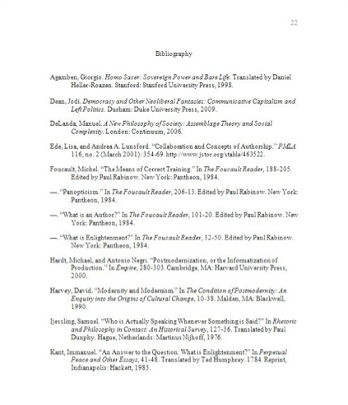

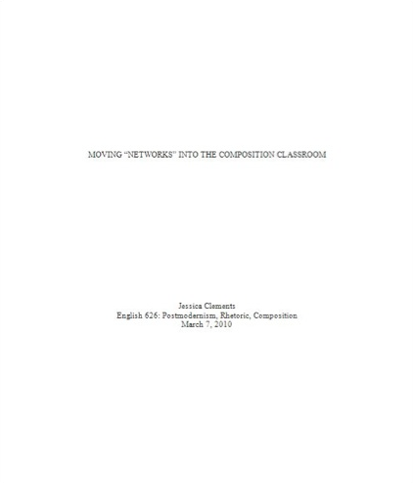

John Steinbeck, Of Mice and Men (New York: Penguin Book, 1993), 33.
Ibid., 39.
Ibid., 43.
Ibid., 49.

